Development - Accelerometer Evaluation
Experiment Description
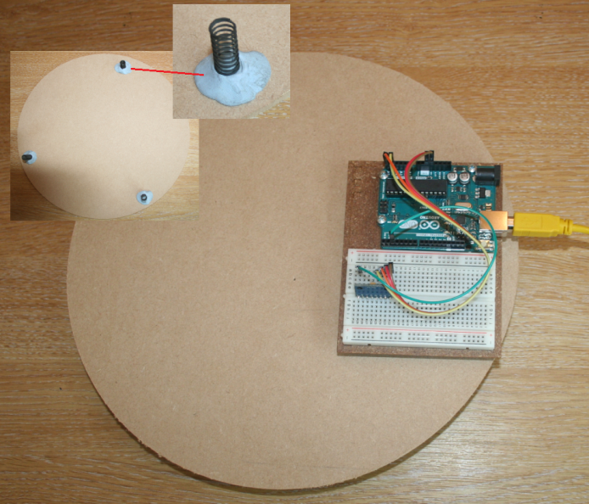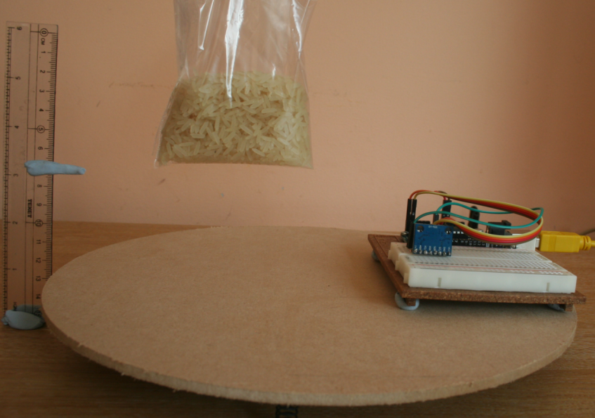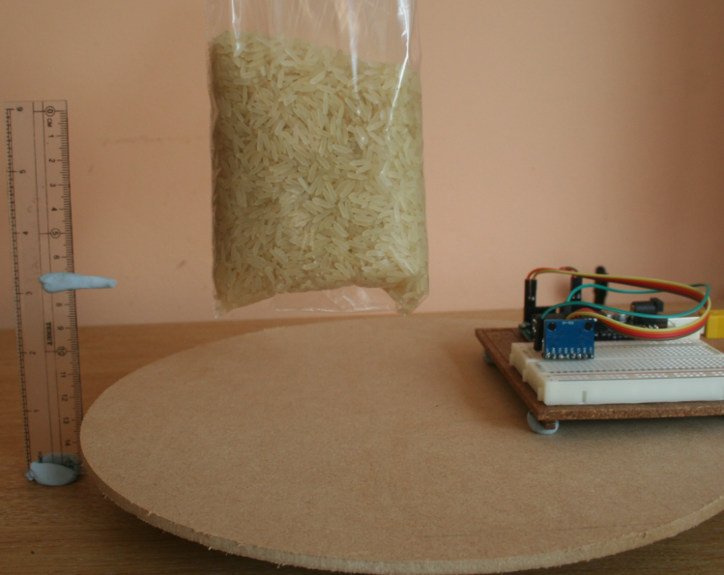
C
B
A
- An experiment was designed to determine if a 3 axis accelerometer (MPU6050) could be used to:
  - Test for the arrival of a bird sized object on a bird table
  - Differentiate between different sized objects (e.g. a robin and a pigeon )
- A 150mm MDF radius circle was constructed a 3 springs attached as feet to allow motion when an object landed (A)
- The accelerometer circuit was attached to the platform (A)
- 2 bags of rice were used to simulate birds: One weighing 30gms to represent a small bird and one weighing 300gms to simulate a large bird.
- Each bag was dropped from the same height (5 cms) and the output of the sensor compared.
Circuit Diagram
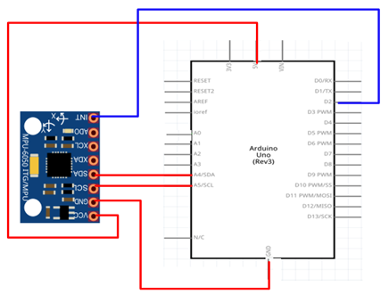
Software
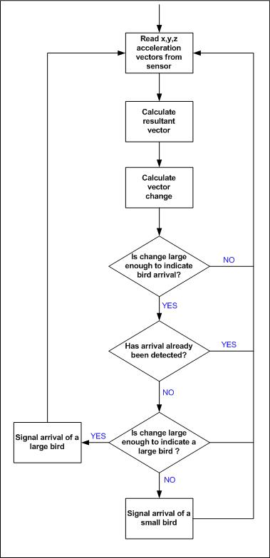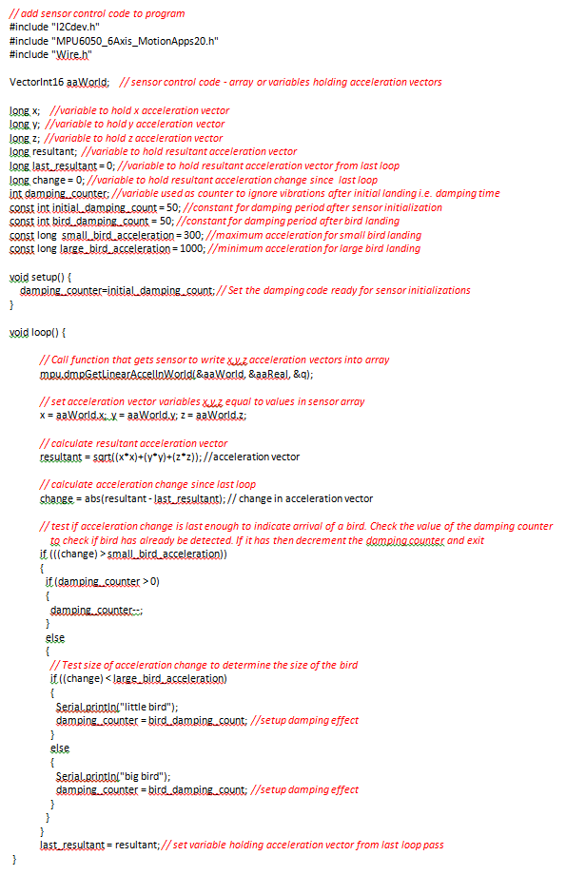
Results
- The x,y,z acceleration vectors are read from the sensor each loop of the programme and the resultant vector calculated. The change in vector compared with the last loop is calculated. A sample output for each bird size is shown below
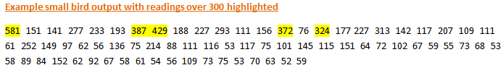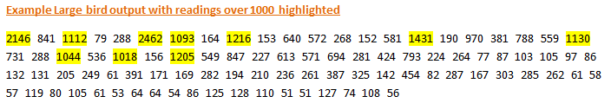
- It can be seen that the oscillation for each landing lasts for many program loops
- The experiment showed that all values below 300 could be ignored, that values in the range 300-1000 indicated a small bird landing and that values 1000+ indicated a large bird landing
- Once a value above 300 was detected readings for the next 50 loops were ignored
- The value was then converted into a bird size as shown below
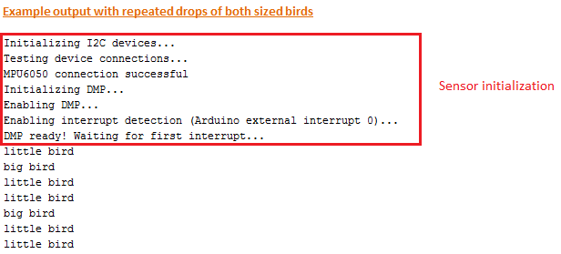
- It was also necessary to ignore the first set of readings after sensor initialization because they falsely indicated a bird landing
